# Coronavirus – Busting Through the Myths

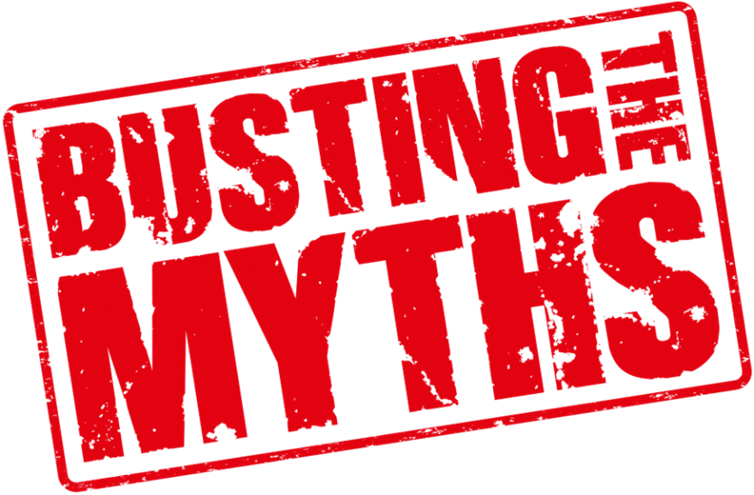New cases of Covid-19 – the disease caused by the novel coronavirus – are cropping up around the world at an increasing pace. And as the spread of the virus continues to stoke fear and apprehension in the minds of the public, the Covid-19 rumour mill has sputtered into overdrive.

Does alcohol gel kill the coronavirus? Is Covid-19 any worse than seasonal flu? And

should I be wearing a face mask? Here are all the answers you need to clear up your coronavirus confusion.

# Myth: Alcohol gels won’t kill coronavirus

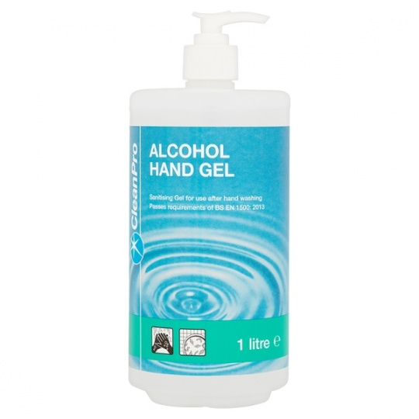Your hands are one of the main routes that viruses make their way from surfaces to your respiratory system, so keeping them clean is one of the most effective things you can do to stop yourself contracting the virus. Wash your hands thoroughly with soap and water for a minimum of 30seconds, where possible, and if you can’t get to a sink, an alcohol-based hand sanitiser will do the trick.

While the effectiveness of alcohol gels depends on the virus being targeted – which is why some alcohol hand rubs aren't very effective against norovirus – the coronavirus has an envelope structure which alcohol can attack. Hand sanitisers with **more than 60 per cent** alcohol content are most effective at killing microbes, but don’t try and make your own sanitiser at home. At best, it’ll probably be less effective than high-street versions and at worse you could end up severely damaging your skin.

# Myth: Covid-19 isn’t more dangerous than seasonal flu

“Why aren’t people this worried about normal flu?” has been the talk of high-street coronavirus experts since the disease first emerged at the very end of 2019. First off, Covid-19 is more deadly than seasonal flu. The average flu strain kills about 0.1 per cent of those infected, but the Covid-19 mortality rate is much higher. Figures from Wuhan, the epicentre of the outbreak, put it at closer to two per cent while figures including deaths outside of Wuhan are lower.

Covid-19 also seems to spread more easily than seasonal flu. The infectiousness of a disease is defined by something called the reproduction number, which estimates how many new infections spring from each case of the virus. Each person infected with Covid-19 appears to infect 2.2 more people on average, but for seasonal flu that number is about 1.3.

Another factor that makes Covid-19 worth worrying about is the fact that it’s a totally new virus in humans. We don’t have any natural immunity or vaccines against Covid-19. And although more than 80 per cent of Covid-19 cases are mild, according to one Chinese study, this makes it more likely that it’ll spread without being detected by health authorities.

# Image result for face maksMyth: Face masks will protect you from the virus

For the average person, regular hand washing is the most important defence against picking up Sars-Cov-2 – the virus that causes Covid-19. Face masks work by blocking droplets from coughs and sneezes that are the main transmission route of coronavirus, but not all masks are effective at filtering out very small particles and viruses can still enter through the eyes.

The only people who really need to wear face masks are those who are likely to be in close contact with infected people. There’s little evidence of a widespread benefit of face masks to the general public, and public stockpiling of surgical masks could make it harder for health workers to acquire them when they need them.

# Myth: A vaccine is just around the corner

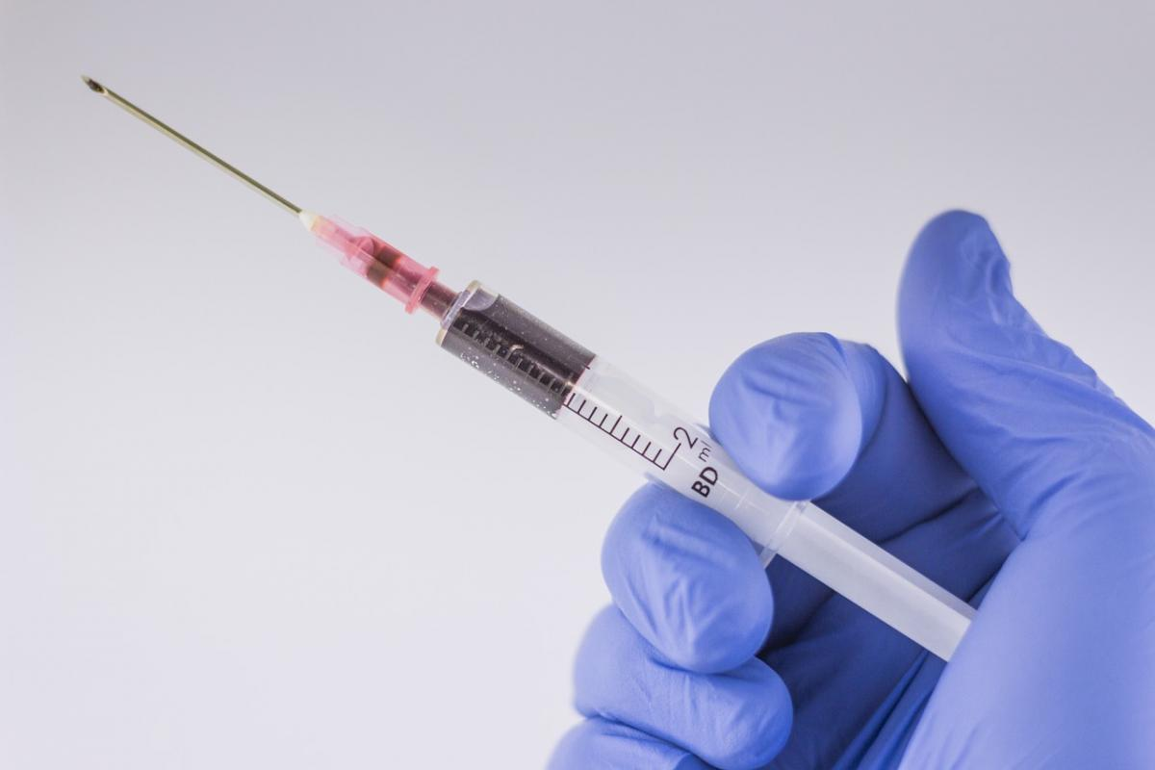Although it took researchers just ten days to release the genome of the novel coronavirus, a vaccine isn’t likely to be ready any time soon. Vaccines have to go through numerous stages of development, including animal and human tests, until they can be widely used so it’s likely to be at least a year before a Covid-19 vaccine is available. By that time, the outbreak may have burned itself out or the disease may already have established itself as endemic.

# Myth: Dogs and cats can catch coronavirus



Reports that a dog in Hong Kong that had tested “weak positive” for the coronavirus provoked breathless newspaper headlines that pets could carry Covid-19. But there is no evidence that dogs or any pet can become sick with Covid-19 and it may well be that the dog that tested positive for the virus had simply picked up the virus from a contaminated virus.

# Myth: Coronavirus only infects older people

Older people and those with pre-existing health conditions tend to be hit with more severe versions of Covid-19. A study of 138 coronavirus patients at Wuhan University hospital found that the virus was more likely to affect older men with pre-existing health conditions, but young people can still contract and spread the disease – especially those who are at very high risk of exposure, such as health workers.

Those with specific health conditions including Cardiovascular, Diabetes, Respiratory, Hypertension may be at higher risk.

# Myth: If containment fails, we should give up entirely

The UK is still in the containment phase of the Covid-19 outbreak. At the moment, health authorities’ main focus is on finding confirmed cases of Covid-19 and tracing the movements of infected people to try and build a map of where the disease is likely to have spread. However, if the increase in new cases rises so fast that containment strategies are no longer possible, this doesn’t mean that we should give up trying to slow the spread of the disease altogether. One of the major risks from Covid-19 is that a spike in cases will temporarily overwhelm the NHS so even if containment fails, health authorities will want to keep this peak as low as possible and spread out the demand on the NHS.



More information can be found on the NHS website -

https://www.nhs.uk/conditions/coronavirus-covid-19/